The Story of The Persolus Race

Alex O’Neill

The text is copyright © 2021 Alex O’Neill.
This version of the text copyright © 2025 Alex O’Neill.

The booklet and its cover art are copyright © 2025 by its creators.

First published in Great Britain in 2021.
This edition published in Great Britain in 2025.

All rights reserved. No part of this booklet may be reproduced in any form or by any electronic or mechanical means, including information storage and retrieval systems, without permission in writing from the publisher, except by reviewers, who may quote brief passages in a review.

Cover art courtesy: Simon Thoroughgood-Hill
Cover text: C. C. Forshee & Alex O’Neill
Copy Editor: Ukchanna K.
Copy Editors on the additional text for the second edition: B. E. Waymire & George O’Neill

Find out more about this booklet and the Persolus Race Universe at thepersolusrace.com

The Story of Volume One

Are we truly alone? This is the question asked, directly or indirectly, in every story of our new anthology, The Persolus Race.
The idea for The Persolus Race came to me slowly and blossomed over a couple of weeks. Initially, when the COVID pandemic came in, I was at somewhat of a loose end and decided to fill my time by getting to work on a piece of creative writing. I consulted my father, who is a lover of classic science-fiction literature. When I told him that I wanted to write a book, he told me that, unfortunately, ”A lot of the good ideas have been done now,” and following this conversation, I had to go away and think about what an interesting twist on a well-established, popular genre would be—my two favourite genres being science-fiction and fantasy.
Slowly, an idea began to form in my head. What would the future be like if humans invented interstellar travel, including light speed, and travelled out amongst the stars, far into the known universe, only to find no other intelligent life—nay, any life anywhere at all?
I liked this idea and slowly it began to form into a plan.
Firstly, I started to think of how it would be best to express this idea. I thought of using one single novel, following one or several adventurers, set after humans had already colonized at least the Milky Way. This, however, didn’t begin to cover the number of potential stories and characters this idea could potentially inspire, and I wasn’t particularly sold on my first book being some enormous space opera similar in length to War and Peace.
I picked up a science fiction short story anthology called The Best Time Travel Stories of the Twentieth Century. I enjoyed it immensely and decided to change tack with the project. I then thought that it was best to think of multiple short stories that fit into this universe and have them all set at different times within the universe in the form of an anthology. I had some worries about how much time this would take, and whether it would affect my completing my master’s degree.
I then had what I’d say was the defining lightbulb moment in the creation of this book: I could give other amateur and semi-professional writers my premise, they could write stories, and then I’d edit the anthology and get it published! I’d never done anything like this in my life, but in that moment, I knew this was something I wanted to do!
I loved this idea, and although I had no idea how to edit and publish a short-story anthology, I set about looking for a Facebook writer’s group that took my fancy. I came across The Sci-Fi and Fantasy Writer’s Guild (SFFWG), and I knew it was the one. I joined and pitched my premise to the group, asking if anyone wished to work on an anthology with me. I got a surprising amount of interest from group members, and I messaged them all, asking if they were willing to be added to a group page that I had put together to work on the book. Before too long, and to my surprise, Rachel Shipp, a copy editor in SFFWG, came forward, willing to work on the book’s grammar for me.
Rachel proved invaluable to getting the book done, and along with one of the contributing authors, M. M. Dixon, supported me in forming a three-person editor’s team. In terms of the authors, I’d had more interest than I’d expected, and before long we had a total of twelve authors from five countries:
- Three Brits (Myself, Jessica Milner, and Steph Millar)
- Five Americans (B. E. Waymire, C. C. Forshee, M. M. Dixon, Melina Munton, and L. E. Doggett), plus our editor to make six total Americans involved in the project.
- Two Australians (Andrew P. McGregor and Josh Whittle)
- One Dutch (M. S. Landwaard)
- One Italian (M. June)
None of us were full-time authors, and we all had other jobs outside of work on this anthology, but we weren’t about to let that hold us back. I was overwhelmed with the enthusiasm the other contributors had for the project, and in turn that increased my own passion for it.
We debated between naming the anthology We Are Alone or The Persolus Race. (‘Persolus’ is a Latin term for ‘alone.’) Well, after polling, We Are Alone only got one vote—mine! But I was pleased to use that in the Prologue title instead. Our rundown of stories looked like this:
- Prologue: We Are Alone by me
- The Man in the Mountain conceived by my father and ultimately written by me
- The Snake in Eden by Josh Whittle
- Oisettio by Jessica Milner
- Chronicles of the Fallen Colony by Andrew P. McGregor
- Starsong by M. M. Dixon
- Thadeus by M. S. Landwaard
- The Seeker by C. C. Forshee
- Empire Reborn by C. C. Forshee
- Undiscovered Nightmare by B. E. Waymire
- Community Service by Melina Munton
- In the Gardens of Eden by me
- The Mine by Andrew P. McGregor
- The Trip Home by L. E. Doggett
- The Placebo Effect by Steph Millar
- The Exhibition by M. June
With none of us having met before, online or in real life, I set up a group chat with everyone in it, plus one with the three editors, and we were off. It was late May 2020, and we all had until the end of August to turn in one story each.
Andrew P. McGregor told me he had already written a thirty-thousand-word novella called Chronicles of a Fallen Colony, which he was happy to edit to fit into the universe. While Chronicles was nearly twice the length of the next-longest story, I was happy to allow it, as the story was great. C. C. Forshee also wrote an extra story called Empire Reborn to line up the gaps in the canon of the universe, which came in at barely five hundred words long. And, finally, my father had promised to write a short story he’d had in his head for many years, about a potential way in which time travel wouldn’t work. As we got closer to the end of August, it looked like his work commitments would prevent him from writing the story, titled The Man in the Mountain, so he gave me the outline, and I wrote it for him.
My other story, In the Gardens of Eden, was a bit of a headscratcher at times. I had recently rewatched the Christopher Nolan film Dunkirk, which had inspired me to write a disaster story, and read a novel called Sleeping Giants, which was told through a series of fictional interviews; I put these together gave me a rough outline for a story, which eventually formed Gardens. I found The Man in the Mountain more straightforward, and I read some classic Arthur C. Clarke short stories to be able to emanate them with my writing.
Jessica Milner put me in touch with a friend of hers, Simon Thorogood-Hill, who designed and then refined our lovely cover design. Enthusiasm really ramped up once we all saw it!
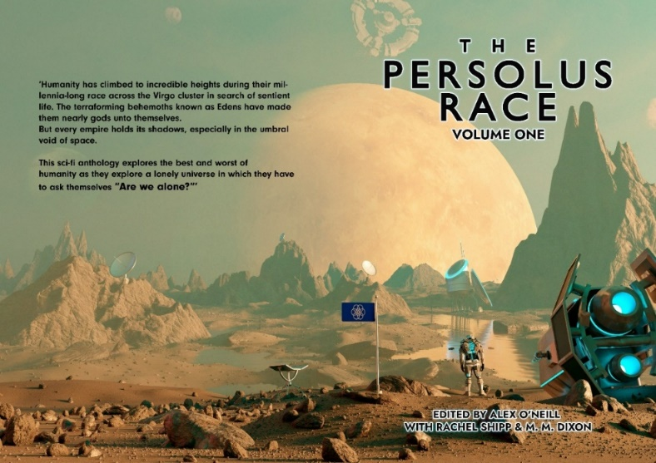
1: Full book cover by Simon Thorogood-Hill
Before too long, discussion within our group chat picked up, and I put together a series of shared documents on the group page to support the book. These included a timeline of the universe, where any major dates within the universe were laid down, and the dates of each story were then added in by their respective authors. This helped us see how the universe would develop, with stories sometimes being moved forward or backward depending on whether they fit into the time appropriately. I also put together a shared document for the authors’ bios, to were listed in the finished book, as well as story summaries, which have been predominantly used in our advertising.
Between May and August 2020, several of the other writers (C. C. Forshee, B. E. Waymire, Andrew P. McGregor, M. S. Landwaard and Steph Miller) and I screened each story as it came in, which involved giving initial feedback to improve the first drafts on. This was all done before the build-up to submitting the stories to Rachel and M. M. at the end of August.
By mid-September, the stories were all in, and the two copyeditors got to work, reading every single story, looking for grammar, spelling, and phrasing mistakes, but also for any plot or canon issues. Discussion with the contributing authors died down, and the editors’ chat began to get more active. Rachel, M. M., and I used a Google sheet to coordinate the progress of each story.
From October to December 2020, there was discourse between the copyeditors and contributing authors, with two rounds of edits as we got towards the end of the year. Rachel and M. M. gave each author suggestions to improve the stories, and then when the authors had edited their stories, they turned them in to be read fully again. The copyeditors then got to work again and returned the stories to their respective authors. This was a long process, but it worked, and the stories were starting to look better and better.
Around this same time, we turned toward how we would publish the book, and whether a print copy would be feasible, given high print prices. First, we looked at going through some form of an official publisher—we figured this was unlikely, given that we were all unknown authors. Several outlets we looked at wanted specific requirements to publish a book, only a few of which we met; in the end, we came to the decision to self-publish through a website called Ingramspark.
The end of 2020 came around, and the book was in the editing process, with almost every story now being on the second round of edits. I set up a document to actually start putting the anthology together. My father wrote a beautiful foreword for the book in which he discussed the history of science-fiction literature and the concept of being alone in the universe, connecting it to Peter Ward and Donald E. Brownlee’s Rare Earth Theory. And, over January and early February, the stories came in one by one into the full first draft.
As a team, we set about seeking beta readers. We gave them approximately a month, along with an attached feedback form for each story, covering how the stories worked, didn’t work, feelings towards central characters, etc., and then summarised the feedback in a table, which we sent to each author. Each author then had a month, in April 2021, to make final edits and return the story to the copy editors for one last look.
I set up some advertising platforms for the book—most predominantly a website, along with contributions from everyone for the About the Authors section. B. E. Waymire wrote a new short story called The Investigator as an online exclusive. I also put together a Facebook page and an Instagram page to boost advertising and increase our outreach. I decided to add the now-complete timeline of the universe into the end of the book as an Appendix, and by mid-May we had a full draft of each edited story. Rachel then gave the book one last full-length proofread, to catch any continuity issues, before 1 June 2021.
During this time, M. S. Landwaard’s friend, Amasja Koolen, put together a second piece of artwork for the anthology, and a friend of Steph Millar’s crafted art for her specific story, The Placebo Effect. These two pieces helped in advertising for the book and may be used in later volumes as well.
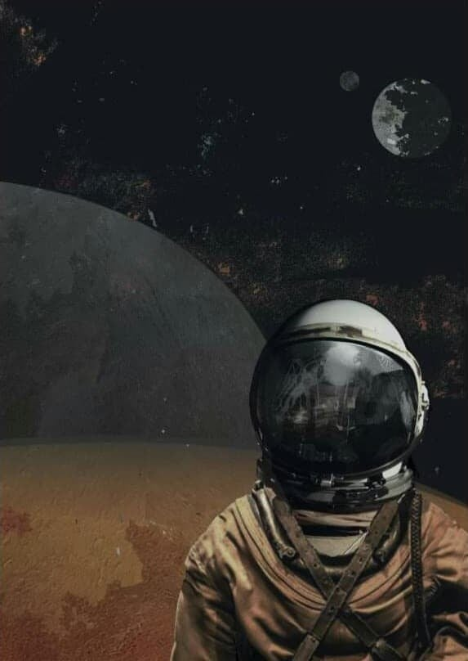
2: Persolus Race astronaut by Amasja Koolen
Both M. M. and I made some formatting edits, while I also, with the support of the contributing authors, went about advertising. This meant regular posts up until the release and sharing the pages where we could. I put together acknowledgements, an afterword, and a dedication for the book, which all of course also needed an editing pass.
Unfortunately, as finally attempted to publish, we hit a snag: Ingramspark needed a spine for the print cover, and we didn’t have one. I looked for online templates, and after not much luck, M. June thankfully came forward with a contact, Andrea Mattevo, who could design us a spine. Simon sent us a layered version of the front cover, and the last push towards getting the book ‘oven-ready’ began.
Andrea managed a quick turnaround on the cover, and then, with some help, I reformatted the book for Ingramspark to accept it. Around this time, we also started looking for ARC readers to give us early reviews, and on 6 August 2021, we received our first review, which described the book as “fascinating and engaging, pulling the reader along with evidence of terrible cover-ups, an altered human species, egocentric artificial intelligence with a master plan, and a futuristic spin on the twelve labours of Hercules.”
I started to think toward the future and contacting small-scale, local comic cons where I could sell the book. I found one local to myself, and other contributing authors came back with similar results. Before too long, we had uploaded all the documents to Ingramspark, and we were ready to send it live for people to purchase. I ordered the very first print copy to check for any issues and waited tentatively for the postal worker to visit. On Friday, 10 September it arrived, and on Sunday, 12 September, I announced on my social media pages that the book was out!
When we started this project, I had no idea it was going to develop into what it became. At its start, my only creative writing efforts belonged in the scribbles of teenage notepads, and by the end, I was a published author. For several of the contributing authors within the project, this book was their first published work. The project was massive, but it showed what could be achieved by a group of strangers who had a shared idea, a range of experiences, and a bucketload of enthusiasm.
So…are we truly alone? I confess I didn’t get to see any aliens on this journey - just as our Persolus Race characters never do - yet I certainly didn’t feel alone.
The Story of Voyages into the Unknown

I always knew that whatever came after the lockdown, after the release of Volume One and the return to relative normality, would be a difficult second album. I knew that I wanted to write more, but I wasn’t sure that I could manage to pull off another large anthology in the form of ‘Volume Two’. After a sad admission to the rest of the Persolus Race writing team that I couldn’t help Volume Two, it all seemed somewhat dead in the water.
After a few months, and having taken Volume One to a couple of comic-conventions, I started finding ideas for more stories set in The Persolus Race universe brewing in my head. Some from Volume One, and some more recent. In April 2022, I suggested to M. M. Dixon that I put together my own anthology of Persolus Race short stories. It was her idea in turn that I find a common theme for all of these stories. I gave it some thought, sketched out the five stories in my head, and eventually the title ‘Voyages into the Unknown’ was born.
The five stories began to take shape; The Man in the Mountain was a story I’d already written and put into Volume One, but whilst managing that project, I felt that it did not get the time it deserved in order to be the story that it could be. In Voyages into the Unknown, it has been expanded and changed enormously, whilst still keeping the same initial concept. It still follows Alex Rehange and his team as they grapple with the very first-time machine, exploring the possible issues and abilities of such a device.
Omniscience, originally titled Malevolence, was an idea started and then left behind by an author called Ted Marois, who had to drop out of Volume One due to personal reasons. In 2022, I contacted Ted, and we agreed that I could finish the story and publish it as part of the next Persolus Race book. His story followed a team of astronauts testing out a new type of faster-than-light engine, one that comes with far more consequences (and is far more powerful) than they first thought.
Timezones was a story of my own invention, coming from the idea of ‘what if you could holiday in different periods from history?’. A Doctor Who story in all but name if ever there was one. A rag-tag group of raiders, somewhere between the Guardians of the Galaxy, the Red Dwarf crew, and bounty hunters from Star Wars, stumble across a very fancy, and very unique space station in quite a predicament. With this story, I wanted to explore the moral dilemmas of the crew members, and have multiple understandable to but differing perspectives on the situation.
Nomads of the Light was an idea presented to me by M. M. Dixon, which we eventually agreed to co-write, and tell in the form of diary extracts. This format and writing agreement made Nomads the most unique writing experience of all the stories in Voyages. Nomads explores the roles people play in society, and how such expected roles can change when placed under stress, with the sales pitch I gave M. M. Dixon being ‘Lord of the Flies in space’.
That left The Dour-Hearted Detective, a detective noir story which followed on from In the Gardens of Eden, my other story from Volume One. The Dour-Hearted Detective would follow the protagonist from that story, Specialist Detective John Morris as he investigated a very different case, while expanding hugely on his character. With this story, we would spend far more time with Morris (as he shared the protagonist role in Gardens) and give him a junior assistant, Emily Machen, who would take on a mentee role for him, one with whom he would regularly butt heads.
Finally, there slightly later edition, The Great Gamble. I’d also had an idea for a full novel set in the universe of The Persolus Race, where a set of outcast space adventurers scoured the universe, using their money and resources to investigate all supposed sightings of aliens. Over time, with a little bit of brainstorming help from my mum, The Great Gamble, a story of the main adventurer (a man I named Gerion) using his old criminal connections to win a ship in a fighting competition, came together. The Great Gamble ended up being an entertaining write, the closest to a comedy of the six stories in Voyages.
Those six stories took up my spare time for the best part of eighteen months, as I changed jobs, moved house, changed careers, and went through highs and lows and my personal life. I came close to calling the book off, thinking my efforts were pointless, twice. Twice I stopped working on it for months.
Now, if you’re skim-reading this, taking in little pieces of information to find out how to successfully self-publish a book of your, then the one key takeaway from this is: DON’T GIVE UP ON A GOOD PROJECT. Even if things are tough, just put it one side for a few weeks, and then pick it up again. Believe me.
Eventually, in September 2024, a full first draft of all six stories was done, and I sent them off, two at a time to some ARC readers. Three contributing authors from Volume One stepped forward – B. E. Waymire, Andrew P. McGregor and Josh Whittle. I then did a round of edits, and passed the book on to my Beta readers, two writing friends of mine, Chloe M. Brown and Michael Tye.
Whilst all this work was going on, I was left with a conundrum. In the meantime, I’d written another story, titled The Woman who Climbed Olympus Mons. A story that followed the event of three professional climbing teams racing to be the first to summit Olympus Mons, the tallest mountain in the solar system. I felt it fit the tone and format of Voyages into the Unknown perfectly, and would make a lovely last-minute edition. I quickly ran The Woman who Climbed Olympus Mons past the arc readers and beta readers, and by May 2025, it was ready to add to the main book.
At the same time, I’d felt that I had more stories I could write about Detective John Morris and his new assistant from The Dour-Hearted Detective, Emily Machen. Enough to fill a whole book of their own, in fact. So, in perfect synchronisation, The Woman who Climbed Olympus Mons went into the book, and The Dour-Hearted Detective came out.
I sent the book to M. M. Dixon in May 2025 for one last look over, then she returned it in July 2025, and I did the final edits to get it ready from Ingramspark once again, the whole process feeling automatic by this point. Andrea Mattevi stepped forward once again to format the cover ahead of release, and what about the cover artwork?
Well, we still had the spare piece of artwork left over from Volume One, the one created by Amasja Kooljen. Amasja gave me her blessing to use the artwork for my own book, and there we were, one stunning looking cover was ready to go:
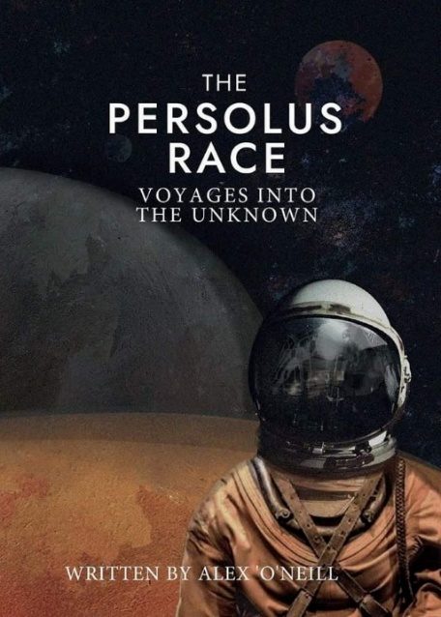

Figure 3: Final cover for Voyages into the Unknown by Amasja Kooljen
From there, Andrea edited the artwork to fit Ingram spark’s website template, my Dad formatted the book, and after a couple of practice runs throughout September 2025, the first test copy of the book arrived in the post of Wednesday 24th September, and on Tuesday 30th September I made the announcement on The Persolus Race’s and my personal social media pages: the book was done, and it was set to come out on Friday 31st October.
Two and a half years back and forth, of writing and editing, The Persolus Race: Voyages into the Unknown was done.
During that time, I’ve taken the Persolus Race books to various comic-cons in Northwest England; Chester, Ellesmere Port, Nantwich, Northwich, Morecambe and Buxton, all run by Toy Cupboard Events, as well as the independently run Stoke Con Trent, Cromford Mills Comic-Con, and Sci-Fi Scarborough. I have found this introduction to the world of small-scale comic con trading to be eye-opening; the people are generous and interesting, the buzz of meeting fans of all sorts of franchises, keen to share with you their interests in the world of Sci-Fi, Fantasy and Horror, to utterly confused parents and grandparents who have been dragged along by enthusiastic children.
And after all this, I know you’ve got one question left…what about The Dour-Hearted Detective?
During the tail end of my time working on Voyages into the Unknown, I realised that I had enough stories around the characters of John Morris and Emily Machen to create a whole other anthology, with each story connecting closely, and following an overarching background plot. I started writing, hoping to make some headway on the project before Voyages into the Unknown. Before long I had a title, two stories written, and the others planned, ahead of the release of Voyages. I even had a title that I knew I would stick with.
What will The Persolus Race: The Interstellar Investigators be about?
Well, you’ll have to wait and see.

The Persolus Race will return soon

From everyone involved in The Persolus Race project:
Thanks for supporting us on this journey!

